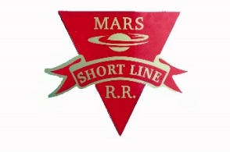
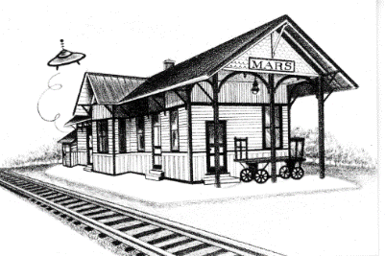
MARS AREA
HISTORY & LANDMARKS SOCIETY
(MAHLS)

“Preserve Yesterday for Today”

December 15, 2019

2019 News, Information, and Opportunities
Important Notice! The MAHLS annual membership banquet is scheduled for Wednesday, January 8, 2019, 6:00 PM @ $22.00 / person, at Luciano’s Restaurant.
Please RSVP by December 31, to Chris Clutter at 724- 625-1115, or email her at Mars2earth@zoominternet.net. Each person is asked to bring a re-gift (ie. a gift you received, but have no use for).
2020 MAHLS DUES can be paid at the dinner, or mailed to our MAHLS address.

2020 MAHLS dues may be paid at the banquet, or sent to our Mars mailing address.

HISTORY IS ALIVE AND WELL IN THE MARS AREA!

Dear Members and Friends,

Following is an excerpt from an acceptance speech by Pittsburgh native and renowned historian / author David McCullough, for the National Book Foundation Medal for Distinguished Contribution to American Letters, in 1995.

“ We, in our time, are raising a new generation of Americans who, to an alarming degree, are historically illiterate.
The situation is serious and sad. And it is quite real, let there be no mistake. It has been coming on for a long time, like a creeping disease, eating away at the national memory. While the clamorous culture races on, the American past is slipping away, out of sight and out of mind. We are losing our story, forgetting who we are and what it’s taken to come this far.”

Although this alarm continues to be sounded by historians to this present day, fortunately in the Mars Area, this situation does not have to exist.

Thanks to a group of dedicated “savers of history” in the Mars area over the years, an equally dedicated current group of volunteers at Mars Area History and Landmarks Society, and the generous donations of funds and items from local citizens and friends … history is being preserved for current and future generations of the Mars area.

The Society campus and historical collection is free and open to children and adults, for review and learning.

As you will see in this newsletter, the Society is continuing to upgrade our historical collection, and make it more accessible in this “electronic” age, as well as expand our ability to display it.

Through our newly formed Innovation and Infrastructure Development Initiative, we intend to share our historical collection with local library, school, or other groups who might be interested in having joint programs with the Society, as well as the greater Pittsburgh area via the University of Pittsburgh Library System.

So, should anyone ask you … History is Alive and Well in Mars!

Sincerely,

John Watson, President

A FUN SEASON FOR MAHLS and the MARS SHORTLINE RAILROAD

The Mars Library sponsored a “Story Telling Walk” from the Library, down Grand Ave. to our MAHLS campus. They started the story at the library, stopped every so often to read another chapter, then finished the story at MAHLS. They then had a picnic lunch, rode the train, and explored our campus. (see photos below)
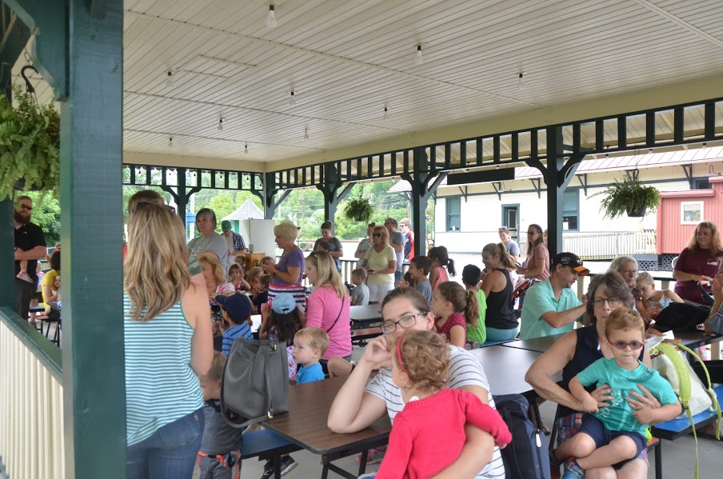
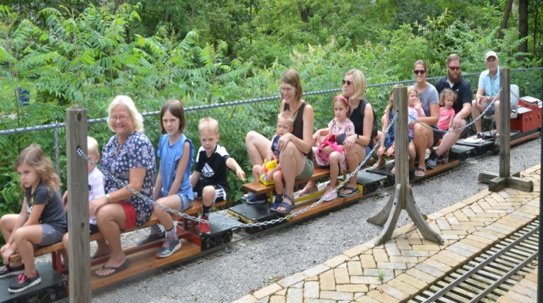

On July 31, as part of a tour of Mars arranged by Mayor Gregg Hartung, we had a large group of State and local visitors come to MAHLS for a tour and train ride. It was an important day for Mars. (see below)
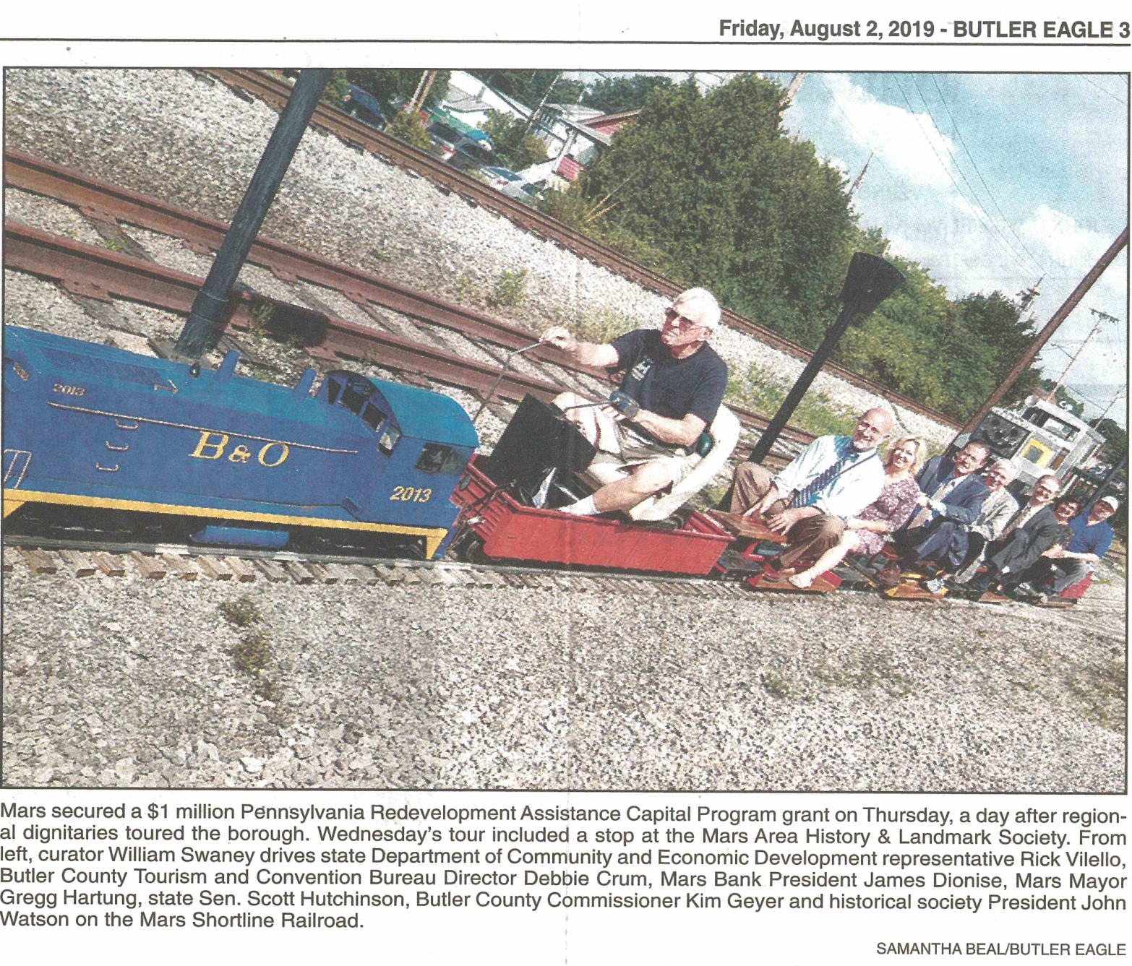
PS: The reason the engineer Bob Lang looks so serious is that he’s thinking, “Oh, please, please train,
don’t derail on this important trip”. It didn’t. The riders were probably thinking the same thing.

A FUN SEASON FOR MAHLS and the MARS SHORTLINE RAILROAD (contd.)

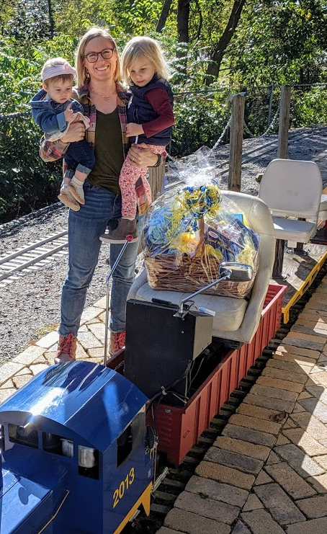
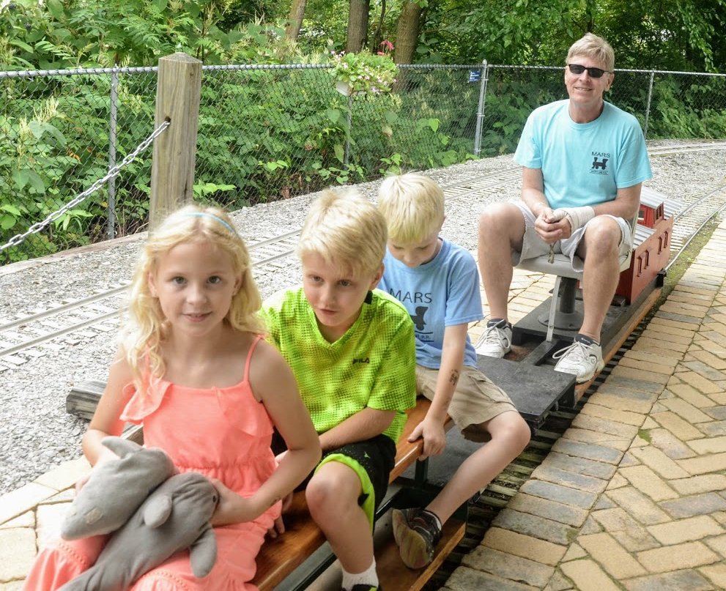

Mars area resident Ryanne Palermo Ellie, a friend, Eddie, and dad Mike Lakes, are one of our most
and her family won the gift basket frequent visiting / riding families. As you can see, Mike even fills in as
that we raffled off during the Mars conductor when needed. They and mom Katie are very faithful friends
Apple Fest. and supporters of MAHLS.

The 2019 Mars Shortline season ended on October 25th. What a day we had to close-out a fun season of train riding, picnics, and exploring our campus.
On our last day, we entertained every age group from babies, to seniors, to severely handicapped persons....and they all loved their experience at MAHLS.
We want to thank a very pleasant group of senior citizens from Penn Mar Plaza in Mars for coming to visit us that day.
As you can see above, our very shy engineer, Curtis Bowers was hiding in plain sight as he skillfully rode the visitors around the MAHLS campus.

Thanks to all of our volunteers who kept the train running and the campus vibrant throughout the season. What a great 2019 season it was.

ALIENS VISITED US TWICE IN 2019 !!!

First, some alien Minions from outer space decided to stay with us…

These Minions were courtesy of Mars area resident Mary Elizabeth who owns
a recycling / environmental / educational firm called “Girl on the Hill Inc”.

The two tall Minions are actually components used in electron microscopes. The short one is an industrial water valve. All made locally.

Talented artists decorated these recycled components for display during the 2019 Mars Lunar New Year’s celebration.

After entertaining visitors at the New Year’s Celebration, the Minions decided to take up permanent residence at MAHLS.

Then Aliens took pictures of us from outer space ….

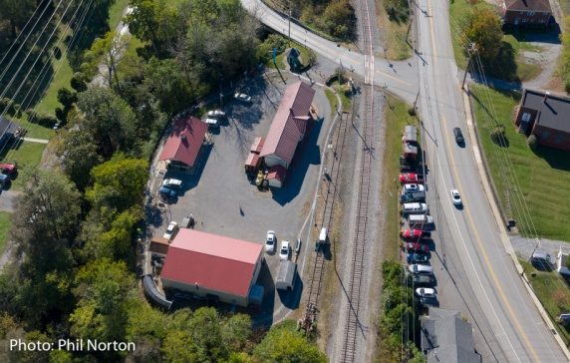
Well, not exactly…

These great aerial pictures of our campus and
volunteers were taken from a drone, that
is owned and piloted by Mars native and
professional photographer Phil Norton, who is the son of our very own Charles Norton.

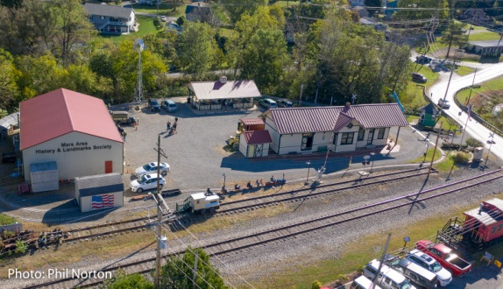
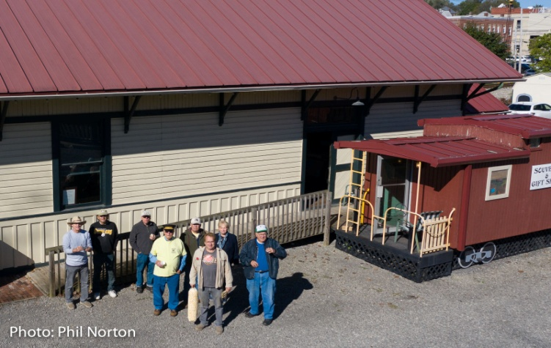

Nice work pilot Phil. Thanks for sharing these photos with us!

AN UPDATE ON OUR 2019 BUILDING FUND

First, a heartfelt thanks to ALL the generous people who made donations to our 2019 Building Fund….and especially one matching donation that took us over the top of our goal.

The building contractor is now generating engineering drawings to submit to Mars officials for review and final permit issuance. The building will be attached to the East side of our main building, and will be a metal structure to match our main building. It will consist of 864 sq. ft. of first floor work shop and storage space, plus additional second floor storage space….size yet-to-be-determined. It is our hope to have construction begin in early Spring of 2020.

Right now, our volunteers are busy preparing the site for the building. The equipment shed currently located on the East side of our main building will be relocated to the West side of the building with the kind assistance of Mars business G.A. Industry’s huge fork truck.

It is also necessary for us to slightly relocate our Mars Shortline Railroad track to the East, with the assistance of Mary Elizabeth of Girl on the Hill Inc. hauling fill for along the bank, and then Fence by Maintenance Service Inc., a new business to Mars donating the chain link fence along the hillside.

Thanks to all the donors, our hard working volunteers, and those people who generously provide assistance and materials to us for making this building addition project happen.

PS: We also want to give a very large Thank You to Judy Langdon, for her donation of her late husband Herb’s shop tools. These will be used in our new work shop in the new building. A very welcome donation.

AN UPDATE ON ORGANIZING OUR VALUABLE HISTORICAL COLLECTION OF THE MARS AREA

In past newsletters, we have talked about the on-going work that our historian Charles Norton, with assistance from other volunteers, has been doing to organize and catalog our collection of documents and pictures of the Mars area. This has been a daunting and laborious task, with the long-term goal of having the files computerized.

Well, thanks to some new member volunteers, as well as existing volunteers, Charles is getting help to move to electronic storage of our entire collection. The new members are Jessica Beasley and Brad Runyon. They and their families live in the area, and found us by bringing their children to ride the Mars Shortline train for the last few years. Long time member and clock smith, Jeff Campbell has also volunteered to join this group.

Just to put an official name to this group, it will be called the INNOVATION and INFRASTRUCTURE DEVELOPMENT INITIATIVE.

INNOVATION being the application of the latest technology used to scan and electronically file the entire MAHLS historical collection into a data base. This data base can be accessed, not only by our members, but by any individual or group wishing to study the history of the Mars area now and in the future.

INFRASTRUCTURE being not only the above mentioned work on preserving the MAHLS historical collection, but also developing outreach to the community. This outreach may take the form of joint educational programs with the Mars Library, collaboration with other historical groups like the Heinz History Center and Historic Pittsburgh (a University of Pittsburgh Library entity), as well as the schools in the area. This work will also include updating our existing website and including access to the newly developed historical data base as it is developed.

In short, not only does MAHLS want to continue to expand and display our collection for all to see, we want to share it with the community at large.

MORE ON HOW THE SMALL TOWN OF MARS, PA. IS ABLE TO HAVE SUCH AN OUTSTANDING HISTORICAL ATTRACTION

Our most important asset is our dedicated group of volunteers, who give their precious time to our Society. Their efforts continue to make MAHLS the jewel that it is. Our volunteers come from all walks of life, and aren’t necessarily originally from the Mars area. But fortunately for MAHLS, they are willing to spend some of their spare time making MAHLS better. For example, following are biographies of three of our dedicated volunteers.

Judy and Rich Ellis (as related by Rich):

Judy and I were both born and raised in the North
Hills of Pittsburgh. We dated each other while
attending North Allegheny High School.
I later went to Pitt and studied civil engineering for a
while and Judy got an associate degree from Robert
Morris.
We decided to marry about the time Judy graduated
from Robert Morris. I quit Pitt to work for a home
builder neighbor who I had worked summers for
since I was 16.

I joined the Air National Guard after quitting Pitt and our unit was activated during the Vietnam conflict. Fortunately, our unit was not required to leave Pittsburgh, so I was able to come home every evening.
Judy worked for Harbison Walker in Pittsburgh and we bought a home in Ross Township.
After six months of activation, our unit was deactivated, and I went to work building homes again.

Our first two children were born while we lived in Ross Township and then we bought our next and current home in Adams Township. It was about a hundred years old. Fortunately, carpentry wasn’t new to me and I enjoyed fixing it up.

Our third child was born in Mars and he is now 46 years old. We probably won’t have any more children. Our children have provided us with even more children, and they all help Judy and me with our phones and computers.

Judy and I have developed a love for the Mars area and the people who live here. We have enjoyed raising our kids in the area and being involved with the activities they participated in. The kids now have their own families and we have redirected our interest into other organizations, primarily, the MAHLS.
We have found the MAHLS a perfect fit for our needs. The members seem to come in all types and interests. The flexible balance between work and play seems to fit all members. Our members have built an attractive facility that is an asset to our community, and is supported entirely by donations and grants.

Curtis Bowers
Curtis is our volunteer with two great personalities....he’s both shy and friendly at the same time.... and he’s also ready to help in an instant on any project.
Curtis spent his childhood and school years in Edgewood (a suburb of Pittsburgh), with his parents, a brother, and three sisters. After high school, the family moved to the country... in Penn Twp. (Butler Co.).
For six years, he learned and worked as a concrete mason. Needing a career change, he became involved in the maintenance and care of golf courses. He also discovered and became proficient at dirt biking in the country.
After moving to Mars, Curtis found MAHLS, and the rest is history. He has become our lead engineer for the Mars Shortline Railroad, and keeps the locomotive in excellent running order. He provides a lot of enjoyment for children and adults throughout the summer and fall. In the past two years, Curtis has also received his Amateur Radio License, and is active in two amateur radio clubs in the area. He enjoys the friendship of, and working with, the volunteers at MAHLS.

IT’S FUN BEING A MEMBER OF MAHLS. WE INVITE YOU TO JOIN US!

As you see throughout this Newsletter, the Society continues to be extremely fortunate to have hard working volunteers with a wide range of skills. If you are reading this, and not a member, please consider joining MAHLS.
No matter what your skill level or interest, there are many rewarding opportunities available at MAHLS…and of course you haven’t lived until you’ve sampled Judy Ellis’s baked goods at 10:30AM break-time every Friday…but you can pick any other day that best suits you…or just be a valued member supporting MAHLS.
If you would like to join MAHLS, please contact our president, John Watson (724-272-9588), to discuss what arrangements might be suitable for you…or just show up on a Friday at 10:30. We look forward to seeing you!

JUST A FEW MORE MEMORIES OF 2019

During 2019, as seen in the photos below, we added and updated our displays and exhibits in our Main Building, as well as in the Train Station.
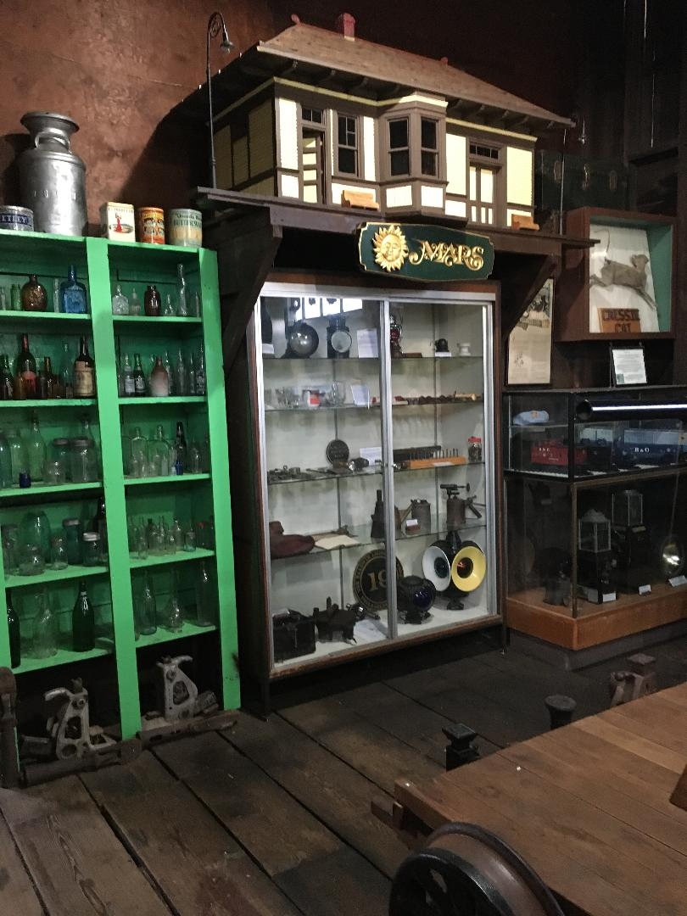
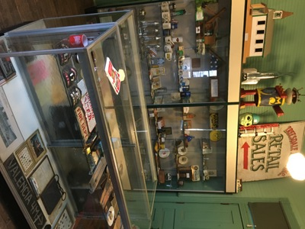

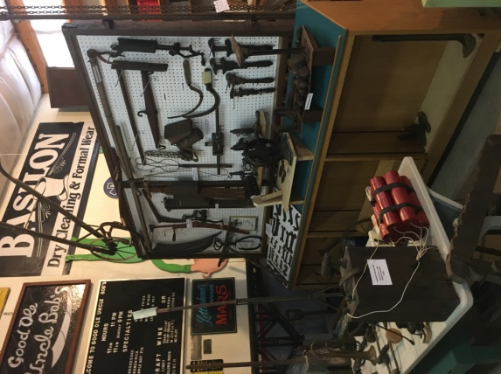

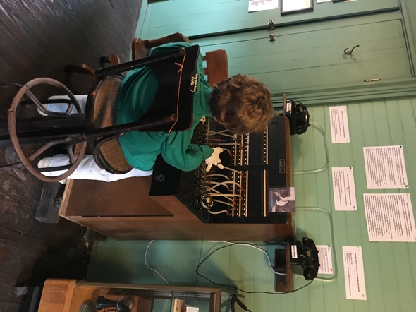

In the center room of the Train Station, we added a Telephone Exchange unit to our extensive display
of vintage telephones. In the mid 1900s, there were
two telephone exchange offices located in Mars.

This unit was donated to MAHLS by Mary Lou and Bill Swaney.

The exchange operator is “Earl”. He doesn’t talk much.

Note: You have to see him to really appreciate him.

Some of our projects at MAHLS require some heavy duty lifting assistance……

The bell is an actual steam
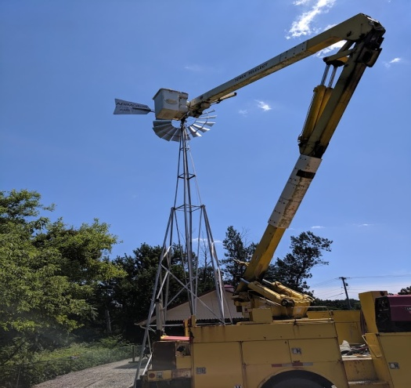
locomotive bell, and is very
heavy.
Thanks to the loan of a truck crane by Vogel Disposal, and operator
Gary McCormick, maintenance was performed on our windmill early this
Summer. (photo on left).
Not wanting to pass up an opportunity, our volunteer Bruce Grinager,
with the help of Rich Ellis, also utilized the crane to start the construction The bell required a very
of a “full front display” of a full size steam locomotive. They are seen in robust mounting structure.
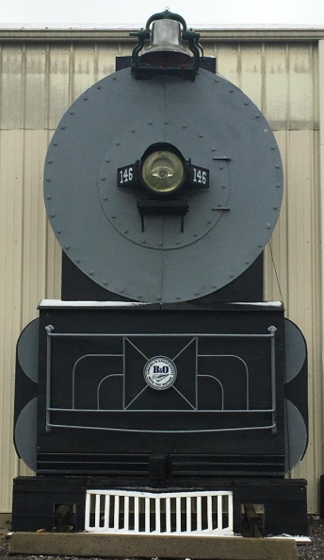
the (above-center photo) mounting a bell donated by Bruce’s family.

The bell is mounted … … and later the boiler front … … and as seen today at MAHLS.

Notes:
As mentioned above, the bell came from a large collection of bells that Bruce’s parents owned.

The headlight seen in the photo on the right was donated by founding MAHLS member, Bill Swaney.

WELCOME DONATIONS LEAD TO PROJECTS FOR NEW DISPLAYS

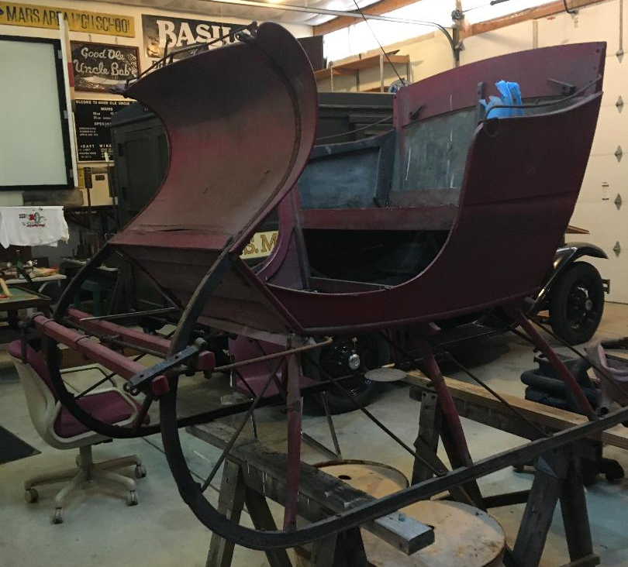
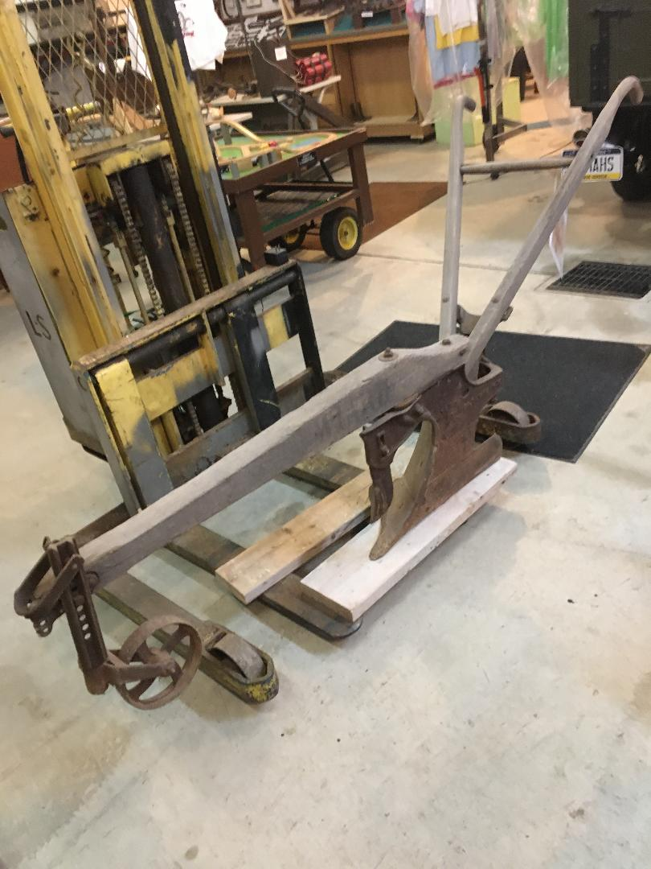

This sleigh was donated by the Thieleman family. Donated by Clyde English of Baden, this single
It was used by a member of their family to blade, horse drawn plough is typical of those
deliver mail in the Mars area. used on farms throughout the Mars area in the late 1800 and early 1900s.

The above two donations are currently being restored in our workshop during the Winter months.

AND FINALLY… ONLY IN MARS, PA.

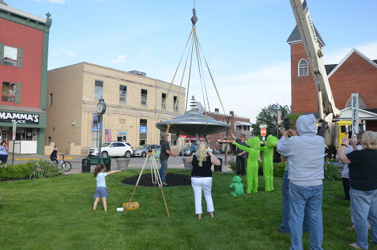
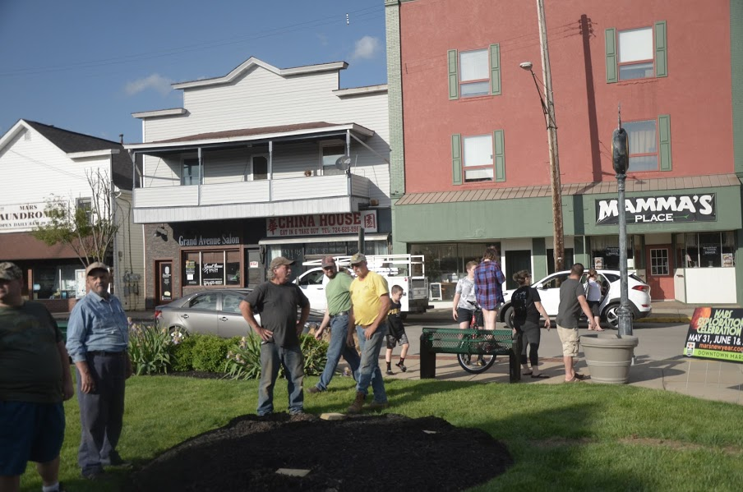
Oh no! Someone stole our Mars Space Ship! Wait! It’s coming back! Thanks to Ron and Gerome Nacey, all is well again in Mars!

------ MARS AREA HISTORY and LANDMARKS SOCIETY -----
(a 501(c) (3) non-profit organization)
Mailing address: PO Box 58, Mars, Pa. 16046 Location: # 1 Brickyard Road, Mars, Pa. 16046
Phone: 724-272-9588 Facebook page: www.facebook.com/marshistory Web: marshistory.org.

Newsletter design and final writing by Bob Lang, with contributions by many MAHLS members. Printed by The Print Shop in Mars.

THANK YOU TO OUR VOLUNTEERS, CONTRIBUTORS, AND MAHLS MEMBERS FOR YOUR SUPPORT

