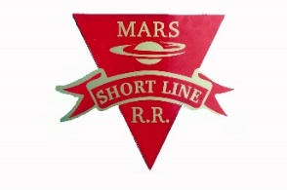
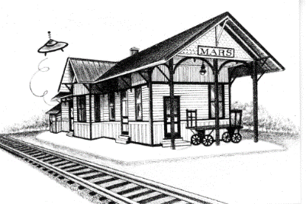
MARS AREA
HISTORY & LANDMARKS SOCIETY
(MAHLS)

“Preserve Yesterday for Today”

December 15, 2018

2018 News, Information, and Opportunities
Important Notice! The MAHLS annual membership banquet is scheduled for 6:00 PM, Wednesday, January 9, 2019, $22.00 / person, at Luciano’s Restaurant. Please RSVP to Chris Clutter at 724- 625-1115, or email her at cclutter@duganandassociates.com. Each person is asked to bring a re-gift (ie. a gift you received, but have no use for).
2019 MAHLS dues may be paid at the banquet, or sent to our Mars mailing address.

Dear Members and Friends,

Hard to believe 2018 is almost HISTORY! You will see in the newsletter there was much accomplished by our dedicated members throughout the past 12 months!!!

Yet, with a heavy heart, I’m sad to say that despite all the achievements this year, due to the necessity of raising funds for an addition to our storage building, there will be no increase of wages for our members. Sorry guys and gals, there’s always next year!

The only thing I can do this year is give out ONE bonus … (drumroll) …the bonus goes out to Bob Lang! Congratulations, Mr. Lang! He gets a lifetime pass to ride on the Mars Shortline. Please, don’t be jealous of Bob’s good fortune folks! Maybe you’ll be the lucky one next time!

My challenge to all of you is to see if you can figure out from the information within our newsletter the member who volunteered to handle ANY outdoor cold weather work, claiming “the colder the better” – aka: The Iceman!

We have a lot to look forward to in 2019; many goals and missions. So, please read the content within our Newsletter.

While we have gained some new members this past year, we are always looking for more helpers. Do you know of any wives that want to kick out their husbands from the house on Fridays? Send them my way!

If I could have one Christmas wish come true, I’d like several members to learn how to make and teach “Rope Making” to the kids. We have a great collection of rope making machines, and I’d like to see them put to use.

Thank you all for being YOU and making life brighter and more fulfilling to your surroundings!

Merry Christmas and Happy New Year!

Sincerely,

John Watson, President

PS: BEING A MEMBER OF MAHLS IS FUN AND REWARDING !

As you will see throughout this Newsletter, the Society continues to be extremely fortunate to have hard working volunteers from a wide range of skills. If you are reading this, and not a member, please consider joining MAHLS.
No matter what your skill level or interest, there are many rewarding opportunities available at MAHLS…and of course you haven’t lived until you’ve sampled Judy Ellis’s baked goods at 10:30AM break-time every Friday…but you can pick any other day that best suits you…or just be a valued member supporting MAHLS.
If you would like to join MAHLS, please contact our president, John Watson (724-272-9588), to discuss what arrangements might be suitable for you…or just show up on a Friday at 10:30. We look forward to seeing you!

OUR FIRST EVENT OF THE 2018 SEASON:

What could be more exciting than an early Spring Wedding at our MAHLS campus!!!

On April 28th, 2018, a beautiful Spring day, a wedding ceremony was held at the “Swaney Station” pavilion on our MAHLS campus.

The bride and groom were Staci Ellis and Eric Nelson. Staci is the granddaughter of MAHLS members Judy and Rich Ellis.

The newlyweds chose a “Roaring Twenties” theme for their attire, to blend in with the architecture of our pavilion. As you can see from the pictures, their plan worked beautifully.

A kind gentleman even brought his 1932 Chevrolet coupe to compliment the event and provide an appropriate background for pictures.

There were close to 100 friends and family witnessing the happy event.

The MAHLS thanks Staci and Eric, and the Ellis family for holding their wedding ceremony on our campus, and we wish the newlyweds a wonderful married life together.

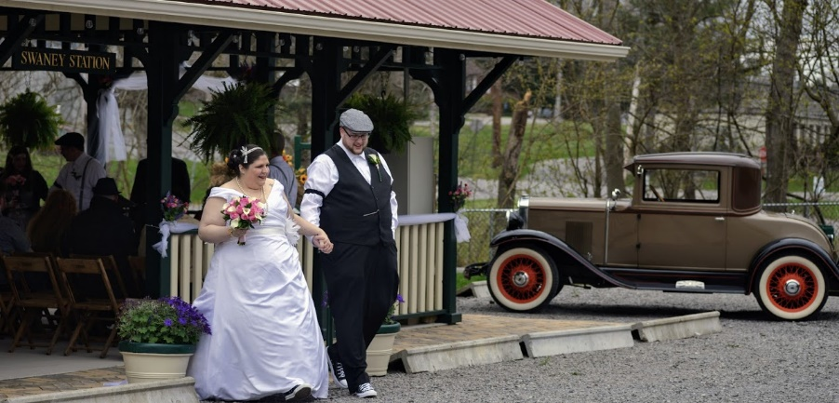
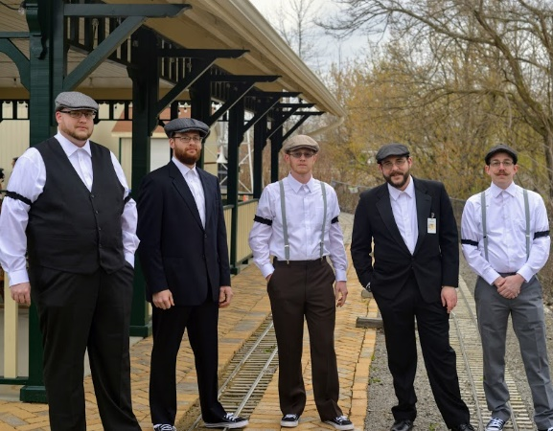

THE MARS SHORTLINE RAILROAD:
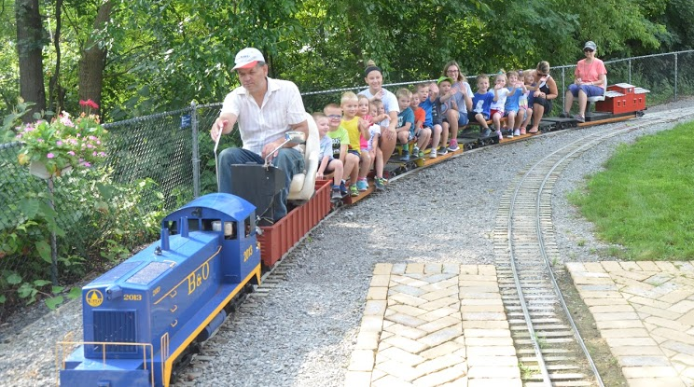
Our railroad continued in it’s 5th year of providing entertaining rides for children and adults from all over the Allegheny, Butler and Beaver counties. In fact, we had several visitors from Canada and Europe as well.

Our Head Engineer, Curtis Bowers kept the train running smoothly, with assistance from many MAHLS volunteers acting as Assistant Engineer, Conductor, Station Master, and Maintenance, as needed. It takes a lot of work to run a railroad.
From late Spring thru early Fall, depending upon weather, we provided from 150 to 300 rides every Friday.

Many families took advantage of our Pavilion, to enjoy a picnic lunch while riding the train and wandering around the campus buildings. We even had some local daycare centers visit us to enjoy the train, explore the campus, and have a picnic lunch.

All in all, it was a great season for the Mars Shortline Railroad for both visitors and staff.

ORGANIZING THE WRITTEN AND PICTURE HISTORY OF THE MARS AREA, AT MAHLS:

As mentioned in last years’ Newsletter, the MAHLS has been actively collecting and storing historical documents, photos and items related to the Mars Area since 1980.

Starting in 2017, our Historian and Curator, Charles Norton, along with members Harry and Nora Paraska, George Lazzo, and John Watson, began a concerted effort to organize all this history.

Meeting most Tuesdays, 12 to 3 PM, these hardworking volunteers are identifying stored items by specific topics. All items belonging to a specific topic are placed in file folders, in cabinets, in our meeting room.

An alphabetical and numerical index has been created for the topic files contained in each drawer. These indexes will be computerized at some point in the future.

Anyone desiring to review and/or receive copies of particular documents and pictures contained in the MAHLS files, can contact Chuck, John, George, or Harry and Nora via our website or in person, to make arrangements.

THE VALENCIA (PA.) HISTORICAL SOCIETY:

The nearby town of Valencia (2 miles S. of Mars — pop. 550 in 2010), has had an active Historical Society for many years. Based at their location in the Valencia Municipal Building, the members have amassed a significant collection of historical items related to the town and surrounding area of Valencia.

Unfortunately, due to lack of active participation, the remaining members have decided to disband, join our Society, and donate their historical collection to the Mars History and Landmarks Society....which MAHLS has accepted. This will happen over the next 6 months. We are looking forward to working with the Valencia members in preserving our area history.

A PLAN TO EXPAND OUR CURRENT MAIN BUILDING ON THE MAHLS CAMPUS:

This past year, there has been a very serious discussion during our Friday work days about how MAHLS might expand our storage space and move our work shop.

After numerous discussions and ideas were tossed around, the best plan seems to be to build a 700 sq. ft. addition (roughly 20’ x 35’, one story with attic), to the East end of our main building. This would be in the area between the main building, the Shortline tracks and the windmill.

The plan would be to move our workshop to this new addition, plus use it to store historical items ... of which there are many, stuffed into many corners of our buildings. Moving all these items, plus new historic donations coming every week, into a storage area would permit us to expand our exhibits and displays in our main building.

We obtained several bids on metal pole buildings, and found that the total cost of an addition of this size and type would be in the range of $50,000.00.

This size of investment is way beyond the financial means of MAHLS. Therefore, we decided to table this building addition discussion until a way can be found to raise the necessary funds…. perhaps a fundraiser or other funding scheme … to be determined. Any ideas are welcome!

Since a new addition is currently not within our means, we have rented some limited second floor storage space in the Doug Weinrich building, located on the Mars-Valencia Rd, directly across the railroad tracks from our MAHLS campus (just to the North of our B&O Caboose).

HOW DOES A SMALL TOWN LIKE MARS, PA. GET SUCH AN OUTSTANDING HISTORICAL ATTRACTION?

Our most important asset is our dedicated volunteers, who give their precious time to our Society. Their efforts have and continue to make MAHLS the jewel that it is. Our volunteers come from all walks of life, and aren’t necessarily originally from the Mars area. But fortunately for MAHLS, they are willing to spend some of their spare time, making MAHLS better and better. For example, following are biographies of just two of our dedicated volunteers….in their own words:

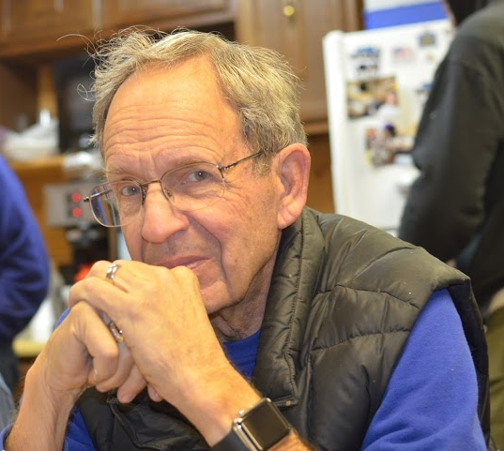
BRUCE GRINAGER:

“I am a transplant, not from around here. I was born in Duluth, Minnesota from where you go south to get to Lake Superior but I grew up in various places in Michigan. Therefore, I don't think these Pennsylvania winters you hate are all that bad.

I grew up liking to take things apart and often, actually getting them back together. Eventually that included automotive things like motorbikes, then motorcycles and cars of various ages. That affliction lingers.

College was at Michigan State with an engineering course with business electives which landed me in the car business…37 years with General Motors…Pontiac, specifically….you remember Pontiacs, don't you? Starting as a technical writer with Pontiac Engineering, after three years I requested a transfer to the Field Organization working with dealers, and was at various times and locations the District Manager in each sales and service. Because of my retirement I think, Pontiac shut down.

I searched Michigan for a wife without success, but after a job transfer to Pennsylvania, I found one quickly. After 54 years and counting it appears things will work out. Peggy and I have three daughters, each of whom completed college, and then when I thought we were done with school bills two of them went back for MBAs. That's OK. They're making them pay off. After collectively living in eight states and four of the five continents, all daughters are back in the US, one in Adams and one on each coast.

My vocation was new cars... my avocation is old cars. I keep a nice 30 Packard, a 39 Cadillac, a 26 Model T Ford, and a 47 Norton motorcycle in my garage, forcing my daily driver to stay out in the snow. Peggy's car stays inside (or I might be outside).

With MAHLS, Classic Car Club, Barbershop Chorus, Lions Club, genealogy, household jobs, and more, I have no idea how some retirees can find nothing to do.

I was asked what drew me to MAHLS. It's simple. I liked what the guys were doing... and I liked the guys that were doing it. And I know how to do a lot of the things that need to be done. And now MAHLS is the only place around that has a name on their John.”
BILL WOLFE:

“Born in Baltimore, Md., I attended grade school and technical high school there. When not attending school, my other interests were making model airplanes, a paper route, and school sports (basketball and football).

While working as a Lab Technician for Grace Chemical after high school, I joined the Air Force, where I saw a lot of the world from the air. Trained as a Radar Navigator, I flew with the Air Rescue Service over the Pacific for three years… then was sent back to the US where I flew B- 29s, looking for Russians over the Atlantic and North Pole…then went on to survey Radar Sites in the Dew and Pinetree Early Warning Lines until discharge.

After the Air Force, I attended the University of Maryland, where I received a BA in Business. This led to work as a concessions manager at sport venues all over the country.
Finally landing in New York City for a while, I married my first wife in 1961 and we began raising a family….eventually growing the family to 1 boy and 3 girls.

Continued next page.

Bill Wolfe, continued from page 4,

In 1963, I landed a job back in Baltimore with Armco Steel Co., working as an Industrial Engineer. Within a year, we were on the move again….transferred to Armco in Butler. From then until I retired in 1993, I served in many different positions, including Industrial Engineering, Yield Supervisor, Superintendent of Production, and finally Planning Sales Manager.

During my working years in Butler, I was also active in United Fund Drug and Alcohol Council, was on the Board of Directors for the Armco Country Club, as well as a VP of the Butler Vagabonds Drum and Bugle Corps.

A few short years after retiring from Armco, my first wife passed away. In 2003, I re-married. Nancy and I settled down in Mars. We enjoy golfing, spending time with friends, and traveling. I have also been active in the Elks, American Legion, VFW, Knights of Columbus, and St. Killian Church.

Having always been interested in volunteering, I joined MAHLS. I’ve made many good friends and like working with the people at MAHLS. It’s fun to have a job to do, and the satisfaction of finishing it. I think that MAHLS is an asset to the Mars Area, and well worth the effort of maintaining and helping it grow.”

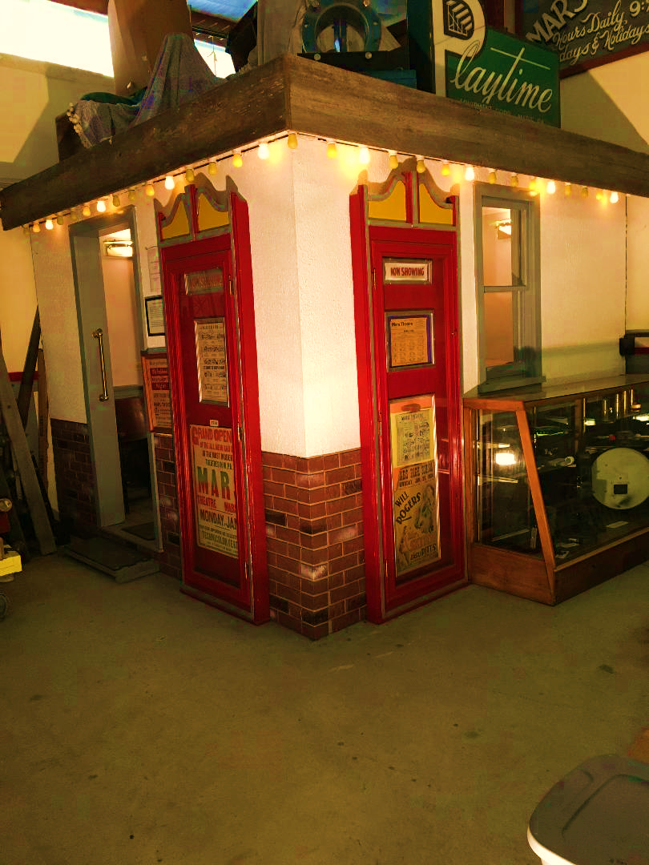
MOVIES IN MARS:

Between the years 1950 and 1960, there was a Movie Theater in Mars…located on Pittsburgh St., in the building currently housing THE MARS PROFESSIONAL BUILDING offices.

MAHLS has preserved this bit of history, by building a small “theater” in our main building, and filling it with items acquired by MAHLS founder/member Bill Swaney, when the original theater building closed.

In addition, our volunteer Gerry Brunson, whose career involved maintaining and operating movie projectors in the Tri-state area, has collected, restored and set-up an exhibit of movie projectors in our main building. One of these projectors is operational, so Gerry can show movies on a special screen built for that purpose.
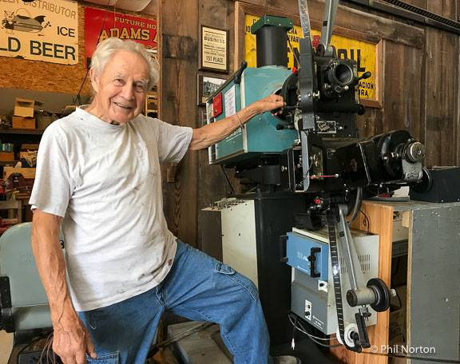

Above photo – Gerry’s display of vintage Simplex movie projectors, with auto-wind film transport system.

Top right photo - the Mars Theater exhibit, located in our main MAHLS building.

Bottom right- Movie Projector guru and MAHLS member Gerry Brunson ready to show movies. (not sell beer)
NEW PROJECT and OPPORTUNITY:

Following our mission statement, ”Preserve Yesterday for Today”, MAHLS is building a new exhibit in the Freight Room of our train station to educate visitors about what Mars looked like during the period 1910 to 1931. The reason for choosing this particular time period is that we have noticed that the majority of Mars Area visitors to our campus are not aware that not only was Mars served by a railroad connected to the 165,000+ mile US national railroad system, it was also served by a local 40+ mile “Streetcar” railroad running from Pittsburgh to Butler via Mars (the Pittsburgh-Butler Shortline).

Our new exhibit will be a 16’ x 7’ “ Diorama “, with operating O-gauge trains and streetcar, plus the main downtown area with small scale buildings and streets. Also included in the exhibit will be the beautifully detailed 1-1/2 scale trolley cars donated previously by MAHLS members, Mary and Al Zamba. These cars are exact replicas of the original P-B Shortline cars.

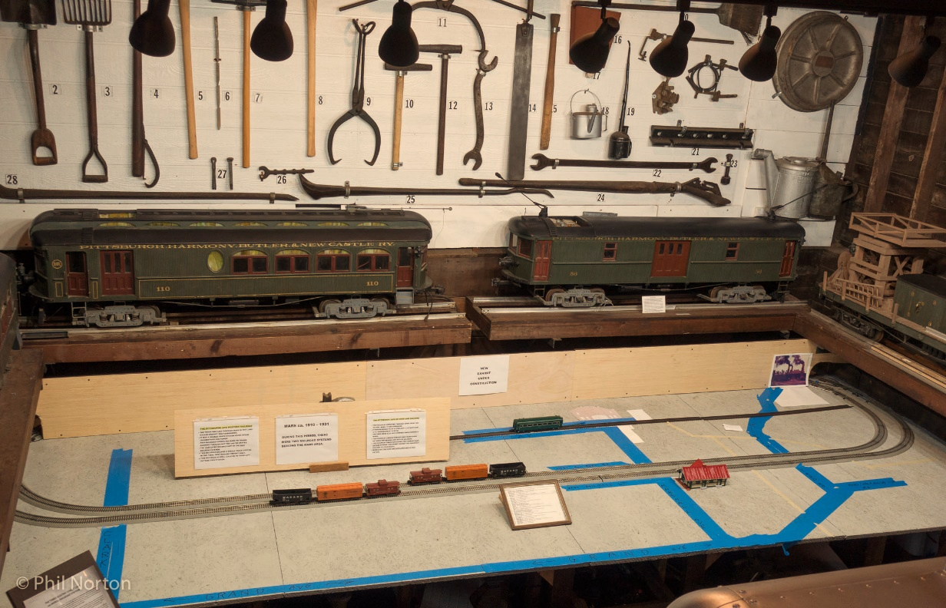

We would like to thank two local Mars companies for their generous expertise on this project. We certainly appreciated both of these companies kind assistance on this project:

J. W. Steel Fabricating Co (located off Mars-Valencia Rd. in Downieville), provided the steel frame structures that support the 1-1/2 scale street cars above the new train layout (see picture above).

Ed Doerschner Machining (Grand Ave. in Mars), provided the machining work on the car support structures.

Ed also recently machined all the wheels on our Mars Shortline riding cars to reduce track wear.

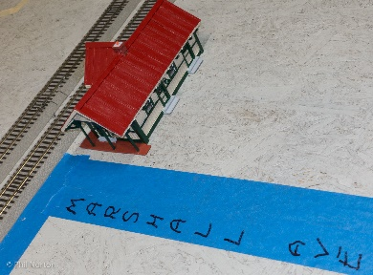
This will be a multi-year project, with the First Phase (3/4 Q 2018 thru 1/2 Q 2019), planned to build the diorama structure, install the railroad tracks and train system, and build some key scale model buildings.

If anyone would like to build one or more scale model buildings for this project, we invite you to volunteer. No prior model building experience is needed...materials and guidance will be provided. Shown at the right, is our first model….the Mars RR Station. This finely detailed model was built and donated to MAHLS by local resident Mr. Terry Colonello.

DONATIONS to MAHLS:

We THANK YOU for all the generous and valued donations in 2018! As always, any and all donations are greatly appreciated…time, historical items from long-time residents, or financial.

Donated items and financial contributions are tax deductible.

Speaking of donations …..

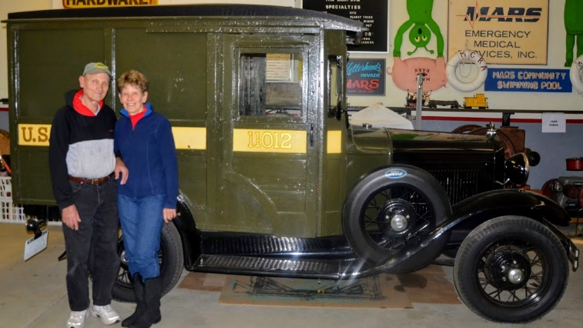
Mary and Al Zamba really surprised MAHLS with a wonderful donation of an original 1931 US Mail Truck.

The truck chassis is a 1931 Ford Model A.
The wooden body was built by York-Harrington Co. of York, Pa.
This mail truck was not used to deliver mail to individual homes. Rather, it was used to transport bulk mail from railroad stations to post offices, from post office to post office, or drop boxes to post office.
These trucks were used from 1929 into the 1950s.
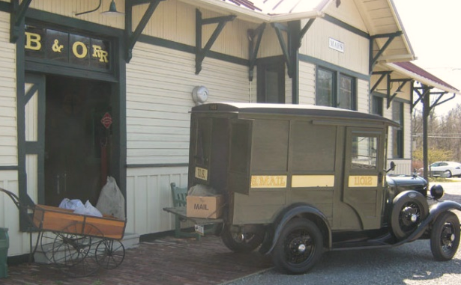
The wooden bodies were brush painted, never spray painted.
This truck body has survived many decades of use and abuse, but still retains its original wood.
The Ford truck is in perfect running condition.

Top photo: Al and Mary Zamba standing in front of the US Mail truck they donated to MAHLS.

Bottom photo: Just as in 1931, the Mail Truck is shown delivering and picking up mail bags at the West freight room loading dock, of our train station.
Also shown is the original Mail Cart used to haul mail bags from the freight room to the Mars post office.

DON’T FORGET TO CHECKOUT THE MAHLS Website and Facebook PAGES:

Our website and Facebook pages continue to be popular references for people to keep up with goings on at MAHLS. We have had as many as 6000 “hits” on some facebook articles. Charles Norton does a wonderful job of keeping these social media sites up to date. Check them out at:
Website: marshistory.org Facebook page: www.facebook.com/marshistory

------ MARS AREA HISTORY and LANDMARKS SOCIETY -----

Mailing address: PO Box 58, Mars, Pa. 16046 Location: # 1 Brickyard Road, Mars, Pa. 16046

Phone: 724-272-9588 Web: marshistory.org.

Newsletter design and final writing by Bob Lang, with contributions by many MAHLS members. Printed by The Print Shop in Mars.
Thanks to all.

BUT WAIT, THERE’S MORE:

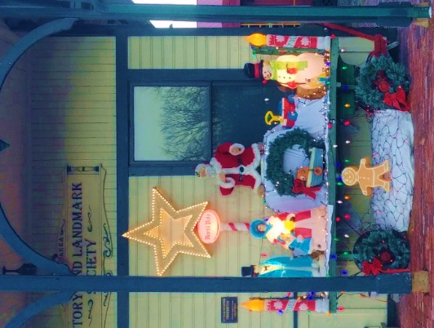
After John Watson’s son Bruce cut a lot of corn stalks out in the field, John and Curtis Bowers spent a lot of time adorning our campus with Fall and Halloween decorations. They were especially impressive at night. Then for Christmas, Jeff Ward and his parents helped to create a Christmas themed display. Nice job everyone!

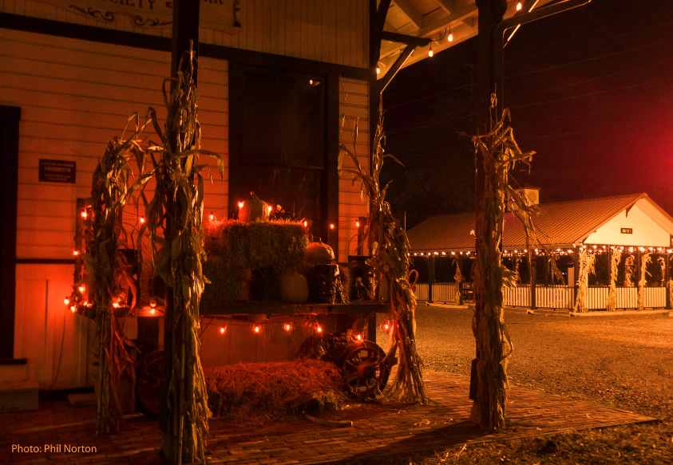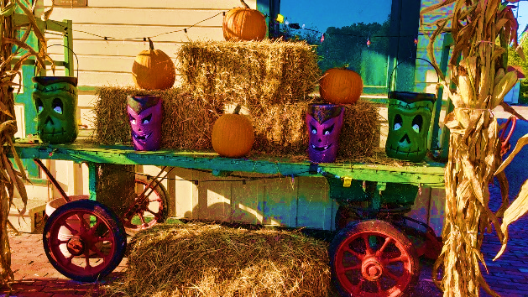

Lost and Found Department:
This past September, we discovered one Friday morning that two very important items were missing from our railroad displays….a green Alien and a Rubber Duck.

Children loved to see and wave to these items as they rode past them on the train.

We placed a “missing stuff report” with the Mars Police, our Facebook page,
and the Mars Connection website.

Low and behold both items reappeared within two weeks!

We thank whomever was responsible for having them returned. It was much appreciated by MAHLS, and a whole bunch of young children.

MAHLS Volunteers Work Hard on Fridays … but after a hard day’s work and enjoying Judy’s pastries, they like to relax and tell stories around the wood stoves.

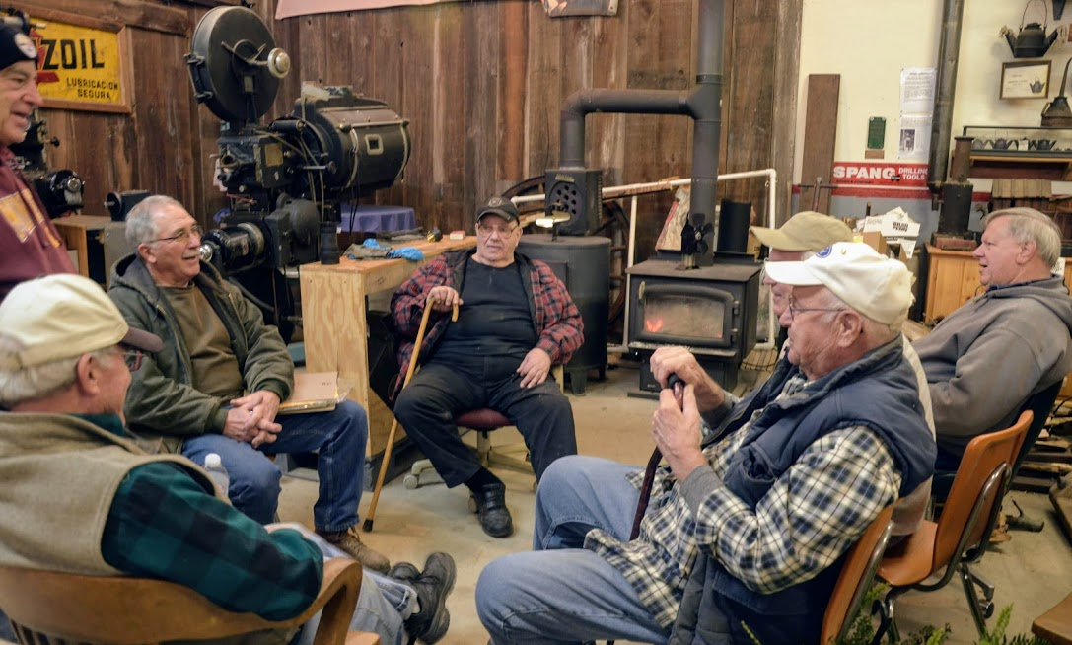
Missing from this picture is our President, who was out cleaning the “Watson John”.

THANK YOU …. to the MAHLS Volunteers, Members, Contributors, and our Visitors in 2018

PS: There were so many wonderful pictures taken in 2018 that could not be included in this Newsletter due to limited space. Therefore, we are making a 2018 MAHLS Picture Collage. To receive a copy, just send your request and email address to langbc23@yahoo.com, and we’ll send a copy to you when it is completed.

