TAKE A TRAIN RIDE
ON THE
MARS SHORTLINE RAILROAD
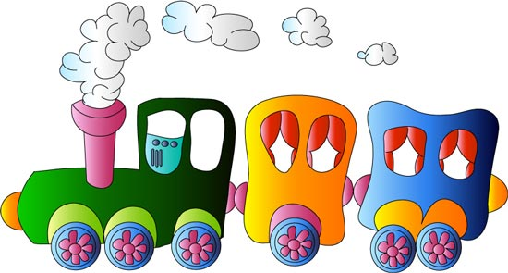

      - SMALL SCALE RAILROAD
      - FOR CHILDREN AND ADULTS
      - EVERY FRIDAY, 10AM – 2 PM
      - MID-MAY THRU NOVEMBER
      - MARS, PA.

