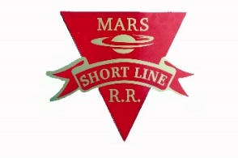
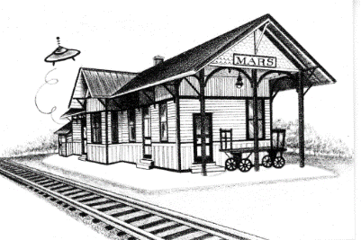
MARS AREA
HISTORY & LANDMARKS SOCIETY
(MAHLS)

“Preserve Yesterday for Today”

April 7, 2019

2019 SPRING NEWSLETTER

What does the word “AREA” mean in our MAHLS name?

MAHLS collects, archives, and displays historical items and records from the following southern Butler County, Pa. communities and townships:

Callery, Cooperstown, Cranberry, Mars, Myoma, Seven Fields, Treesdale, Valencia, as well as Adams & Middlesex Townships.

Anyone desiring to review and/or receive copies of particular documents and pictures contained in the MAHLS files, can contact MAHLS via our website, or in person to make arrangements.

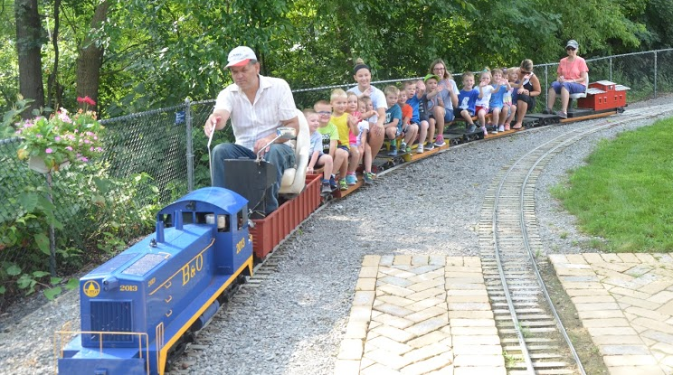
THE MARS SHORTLINE RAILROAD:

Our railroad continued in it’s 6th year of providing entertaining rides for children and adults from all over the Allegheny, Butler and Beaver counties. In fact, we had several visitors from Canada and Europe as well in 2018.

From late Spring thru early Fall, depending upon weather, we provide from 150 to 300 rides every Friday.

Many families take advantage of our “Swaney Station” pavilion, to enjoy a picnic lunch while riding the train and wandering around the campus buildings. Some local daycare centers visit us to enjoy the train, explore the campus, and have a picnic lunch.

Depending upon weather, we hope to have the railroad up and operating on Friday, May 24, 2019.

THE VALENCIA (PA.) HISTORICAL SOCIETY:

The nearby town of Valencia (2 miles S. of Mars — pop. 550 in 2010), has had an active Historical Society for many years. Based at their location in the Valencia Municipal Building, the members have amassed a significant collection of historical items related to the town and surrounding area of Valencia.

Unfortunately, due to lack of active participation, the remaining members have decided to disband, join our MARS Historical Society, and donate their historical collection to the Mars History and Landmarks Society....which MAHLS has accepted. This will happen over the next 6 months. We are looking forward to working with the Valencia members in preserving our area history.

A NEED FOR MAHLS TO EXPAND:

The MAHLS has been actively collecting and storing historical documents, photos and items related to the Mars Area since 1980.

This extensive collection of Mars Area History is stuffed into many corners of our buildings….and we are fortunate to receive new historical documents and artifacts weekly.

In addition, with the merging of the Valencia Historical Society into the MAHLS buildings, we have no space to store or display their extensive collection, and will be forced to rent storage space off campus.

As you can see, we must expand our facility!

A Plan:
The plan is to build an addition to the East end of our main building. We will move our workshop to this new addition, plus use it to store historical items.

The addition of this planned storage and workshop facility will permit us to expand our exhibits and displays in our main building, as well as in our restored 1897 B&O Railroad Station.

Project Cost:

Based on engineering and supplier estimates, the total cost of this addition, utilities, and other required infrastructure, will be $65,000.00, including infrastructure changes.

Donations:
If you would like to make a donation to our 2019 MAHLS BUILDING ADDITION FUND, donations can be made in 3 ways:

- Checks can be sent to our address below. (please indicate “for 2019 MAHLS BUILDING ADDITION FUND”)
- Cash donations can be brought to our MAHLS campus, any Friday, from 10:00 AM until 1 PM.
- MAHLS has setup a GOFUNDME campaign at https://www.gofundme.com/2019-building-addition-fund

BEING A MEMBER OF MAHLS IS FUN AND REWARDING !

The Mars History and Landmarks Society continues to be extremely fortunate to have hard working volunteers from a wide range of skills. If you are reading this, and not a member, please consider joining MAHLS.

No matter what your skill level or interest, there are many rewarding opportunities available at MAHLS…and of course you haven’t lived until you’ve sampled our volunteer Judy’s baked goods at 10:30AM break-time every Friday…but you can pick any other day that best suits you…or just be a valued member supporting MAHLS.

If you would like to join MAHLS, please contact us at (724-272-9588), to discuss what arrangements might be suitable for you…or just show up on a Friday at 10:30. We look forward to seeing you!

MARS AREA HISTORY and LANDMARKS SOCIETY

Mailing address: PO Box 58, Mars, Pa. 16046 Phone: 724-272-9588
Location: # 1 Brickyard Road, Mars, Pa. 16046 Web: marshistory.org
Email: marshistory@gmail.com

